Music Box Presentation Checklist & Rubric

This is a checklist, make sure you complete all these tasks in order to get the best grade possible
Students create a presentation, all members contribute
Slide #1 has Theme & Student Name(s) listed
Presentation features at least 5 items with pictures
Students create a budget for project (final slide)
Students present to their peers.

This is a rubric. It tells you how you will be graded on each of the items above.

Students create a presentation and all members contribute
10  All members contribute equally to a quality presentation | 8 | 6  Presentation is complete but some members did not contribute fairly | 4 | 2  Presentation is not complete or some members did not contribute at all.

The title slide features the Theme and names of group members
10  The slide has all required information | 8 | 6  Title slide is missing some information | 4 | 2  Presentation does not feature this information

Slides feature at least 5 items with names, descriptions, and picture.
All items must relate to the theme of the project.
10  Slides contains all required components | 8  Slides contains all components for at least 4 of the items | 6  Slide contains all components for at least 3 of the items | 4  Slides contains all components for at least 2 of the items | 2  Slides contains all components for at least 1 of the items

The Budget features the cost of all items, amount charge, and profit made.
Both for individual purchase and yearly subscriptions
10  Budget contains all required components | 8  Budget contains all components but basic math is incorrect | 6  Budget is missing a single component | 4  Budget is missing several components | 2  No budget was turned in.

Students present their work to their peers
10  Students present work and all students contribute.  Students are respectful during the presentations of others. | 8  Students present work and most students contribute.  Students are mostly respectful during the presentations of others. | 6  Students present work and some students contribute.  Students are off-task during the presentations of others. | 4  Students present work and some students do not contribute.  Students are disruptive during the presentations of others. | 2  Students do not present or are disrespectful to others while they present.

Final Score: __ /50
Sample Budget
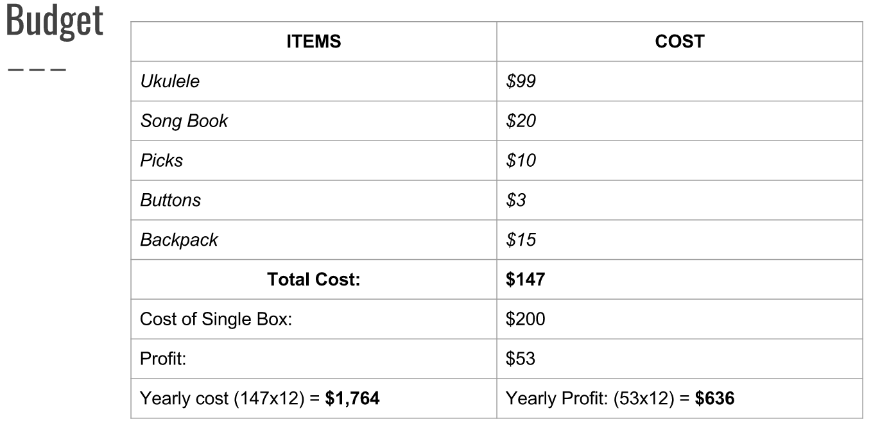
Blank Budget
ITEM | COST
1
2
3
4
5
TOTAL COST
Charge for a single box
Profit
Yearly Cost: | Yearly Profit:

