NAME: ____________________________________ ABA Songs

Make your own ABA song by cutting out the different shapes and pasting in the boxes below.
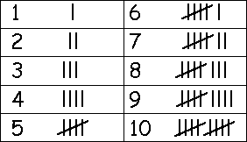
Use tally marks keep track of how many times you will play each part!

A | B | A

